SIMATS ENGINEERING
ASSESSMENT TOOL 2: Concept Mapping

COURSE NAME: COMPUTER VISION COURSE CODE: ITA05

COURSE OUTCOME COVERED

CO1: Apply the fundamental concepts, image formation models, and processing techniques for analyzing Computer Vision systems. (BTL 3)

Assessment Tool Weightage: 20%

- Construct a comprehensive and well-organized concept map that accurately identifies all key concepts from literature involved in the pipeline from real-world scene capture to digital image representation, establishes clear and meaningful relationships among intermediate transformations and dependencies, integrates insights from multiple studies, and presents the information in a clear and visually structured manner.
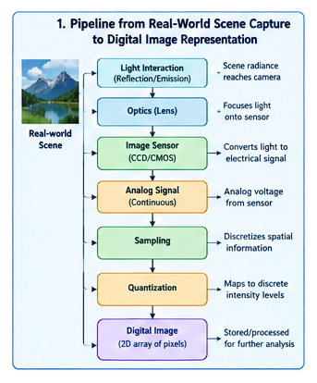
- Develop a hierarchically structured concept map that identifies major stages of visual data handling in a Computer Vision system, clearly illustrates logical relationships and contributions of each stage toward generating meaningful outputs, incorporates relevant literature connections, and ensures clarity and readability.
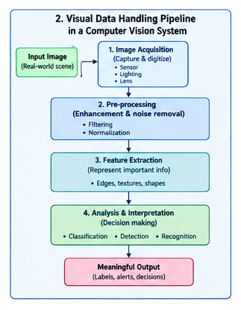
- Create a detailed concept map that accurately identifies concepts related to image resolution and intensity levels, establishes clear cause–effect relationships with image quality and usability, integrates supporting evidence from literature, and presents the concepts in a logically organized and visually clear format.
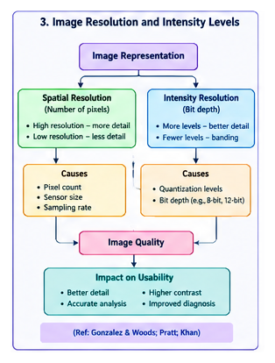
- Design an analytically organized concept map that identifies key factors in image acquisition conditions, clearly links them to downstream processing and application performance through meaningful relationships, integrates findings from relevant studies, and ensures a well-structured and easy-to-interpret presentation.
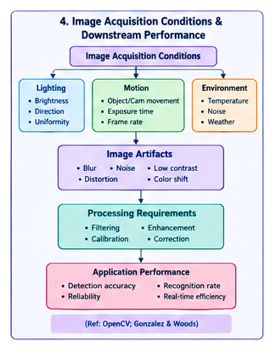
- Construct an original and logically structured concept map that identifies system capabilities and their influence on the selection and effectiveness of vision-based applications, establishes clear interconnections, integrates multiple literature perspectives, and maintains high clarity and visual organization.
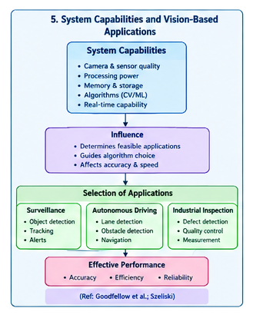
- Construct a concept map that identifies the complete workflow of digital image formation, clearly linking sensing, sampling, and quantization stages with their impact on image quality, integrating relevant literature insights, and presenting the relationships in a structured and visually coherent manner.
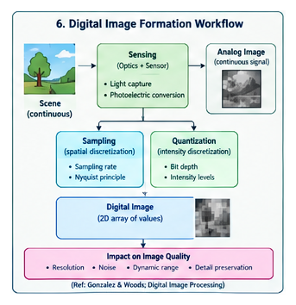
- Develop a concept map that identifies different levels of Computer Vision, establishes relationships between low-level processing, mid-level analysis, and high-level interpretation, integrates literature-based examples, and ensures clear hierarchical organization.
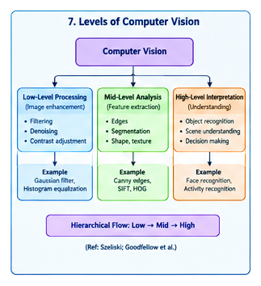
- Create a concept map that identifies factors affecting spatial resolution, clearly linking them to sampling rate, pixel density, and application requirements, incorporating supporting evidence from literature, and presenting the structure with clarity.
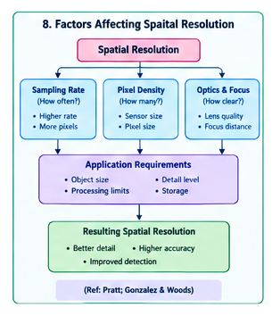
- Design a concept map that identifies the role of image sensing mechanisms, clearly establishing relationships between sensor characteristics, noise generation, and acquisition quality, integrating literature perspectives, and ensuring logical flow.
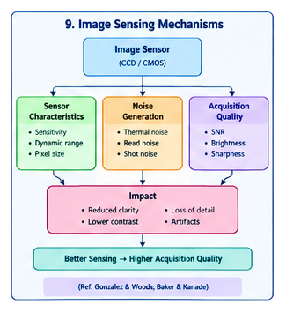
- Construct a concept map that identifies the relationship between sampling, aliasing, and image distortion, clearly illustrating cause–effect dependencies, integrating relevant theoretical insights, and presenting the structure in a visually organized manner.
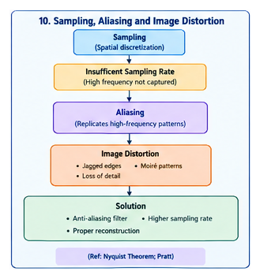
- Develop a concept map that identifies quantization processes and their impact on intensity resolution, clearly linking quantization levels to image quality degradation, incorporating literature references, and ensuring structured visualization.
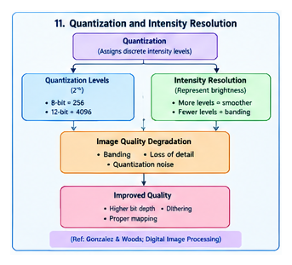
- Create a concept map that identifies the relationship between image acquisition conditions (lighting, motion, environment) and resulting image artifacts, integrating findings from literature and presenting clear interconnections. 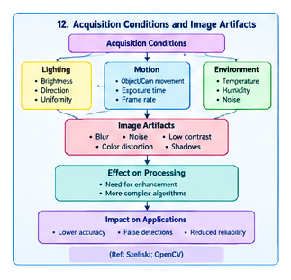
- Design a concept map that identifies the transformation from analog scene to digital image, clearly linking physical processes to computational representation, integrating literature-based insights, and ensuring clarity and organization
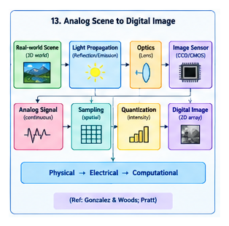.

- Construct a concept map that identifies dependencies between image quality parameters (resolution, noise, contrast) and system performance, integrating multiple perspectives from literature and presenting structured relationships.
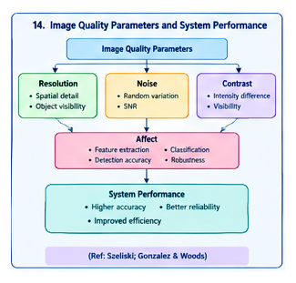
- Develop a concept map that identifies interactions between image formation models and Computer Vision applications, clearly linking theoretical models to practical system performance, integrating literature insights, and ensuring visual clarity.
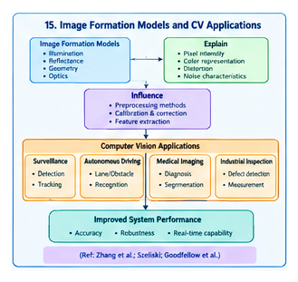

Code of Conduct:

I S.PRATEEKSHA-192572137 (Name / Reg No) certify that this submission is my original work and that I have adhered to the guidelines specified for this assessment.
I understand that any violation of academic integrity rules will result in disciplinary action.

Signature of the student:S.PRATEEKSHA

RUBRICS FOR CALCULATION:

Criteria | Weightage | Level 4 (Exemplary) | Level 3 (Proficient) | Level 2 (Developing) | Level 1 (Beginning)
Concept Identification | 25% | Identifies all key concepts from literature accurately and comprehensively | Identifies most key concepts with minor omissions | Identifies limited concepts; some are irrelevant or missing | Fails to identify essential concepts
Linkages | 25% | Establishes clear, meaningful, and accurate relationships between concepts | Shows correct relationships with minor gaps | Relationships are weak, unclear, or partially incorrect | No meaningful relationships established
Organization | 20% | Concepts are well-structured hierarchically with logical flow and grouping | Mostly organized with minor structural issues | Some organization but lacks clear hierarchy | No logical organization or structure
Integration of Literature | 20% | Integrates multiple studies effectively to show connections and comparisons | Shows some integration of literature | Limited integration; mostly isolated concepts | No integration of literature evidence
Clarity | 10% | Concept map is clear, neat, visually structured, and easy to interpret | Generally clear with minor readability issues | Clarity is reduced; difficult to interpret in parts | Poorly presented and hard to understand

